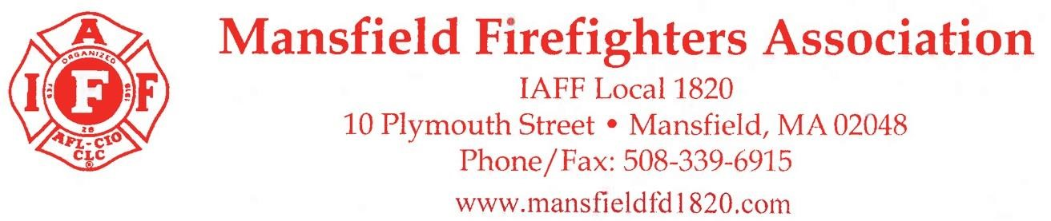

Mansfield Firefighters Association is hosting our Annual Charity Golf Tournament at Norton Country Club, 188 Oak St Norton, MA 02766. This will be held on Monday May 20th, 8:00am registration, 9:00 AM shot gun start. Proceeds from this tournament help support our associations operating expenses and all our charitable events throughout the community. This couldn’t be done without you, our sponsors, and the golfers. We hope you can help us again this year.

• Hole Sponsor ($200)
Signs place throughout the course on the tee boxes, Great way to show your support for MFD L1820.

Fill out Sponsorship Form and Attach Business Card for Sign

Business Name & Contact ______________________________________________________

Address ___________________________________________________________________

_____________________________ ____________________________________
Phone Email

Mail checks to: P.O. Box 172, Mansfield, MA 02048.

Any questions please Contact: Call/Text Kyle (508)245-1363

Thank you,

Golf Committee
Mansfield Firefighters, Local 1820

Mansfield Permanent Firefighters is a 501(c) (5) 0rganization. Tax ID #: 23-7062864

